Using Copilot in MS WORD 365

Word with the Copilot function shown in the menu. A paragraph of text has been typed in for this demonstration.
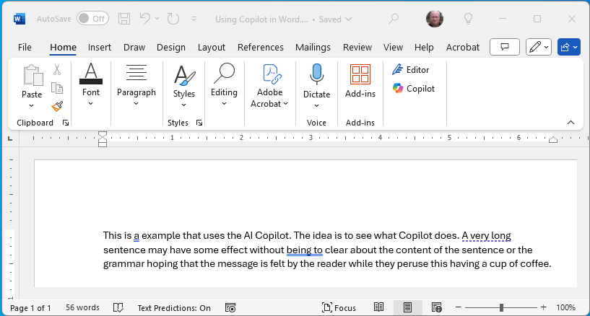

Click or tap
The editor side panel has the following:
- Editor Score
- Formal writing
- Correctios
- Refinements
- Similarity
- Insights

This appears in your Word Window as shown below:

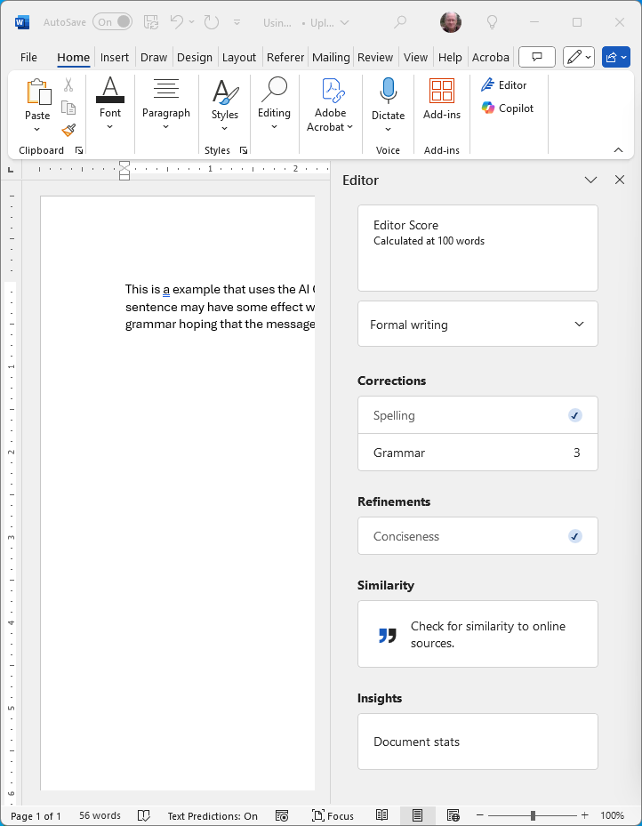

Click or tap each to activate. The results are presented below:
Editor Score
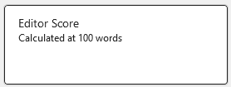
Formal writing
In this demonstration it is set to Casual
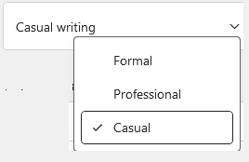
Corrections
The spelling and grammar are corrected in the document. Spelling errors are marked in red, grammar errors in blue.
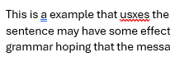
In the Editor panel the number of occurrences is shown:
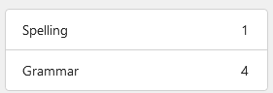
Refinements
The author’s example appears to be, OK? Imagine that.
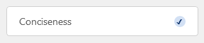

Similarity
The process took about 10 minutes. A message that it was checking displayed until this one appeared. The author did not expect an answer. See below for an example that should work.
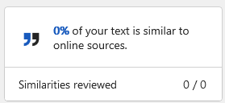

Insights
Clicking or tapping the Document Stats box produces:
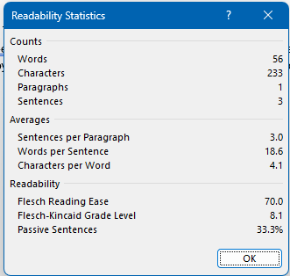

In the WORD document menu clicking  produces the following:
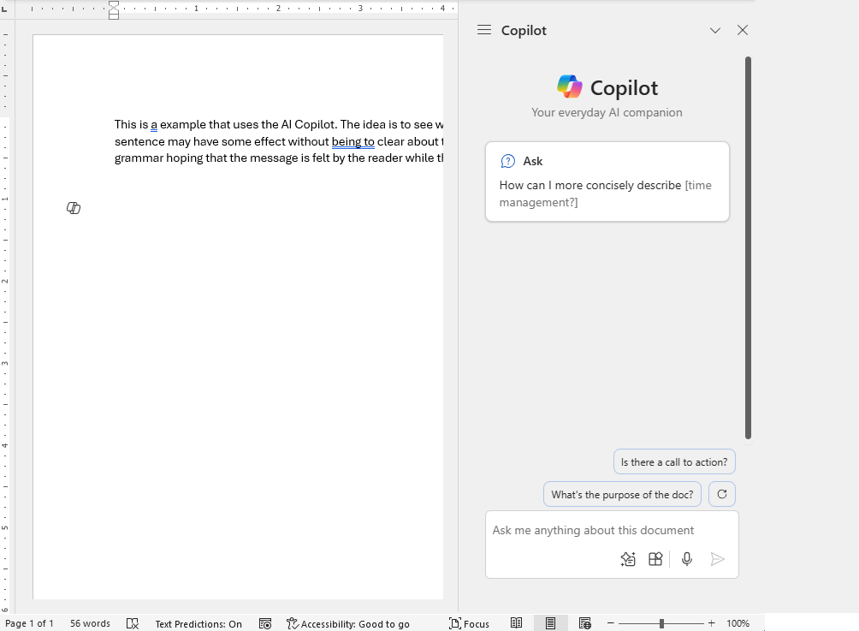
Click on this.
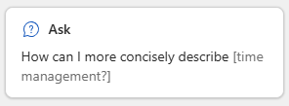
Put this suggested question into the question box:
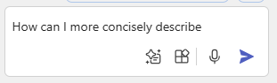

This is the answer:

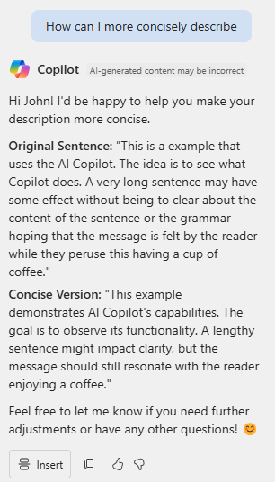

The following is an example of Copilot where the author asks for a Similarity check. First, the text to be checked, followed by copilot’s answer.
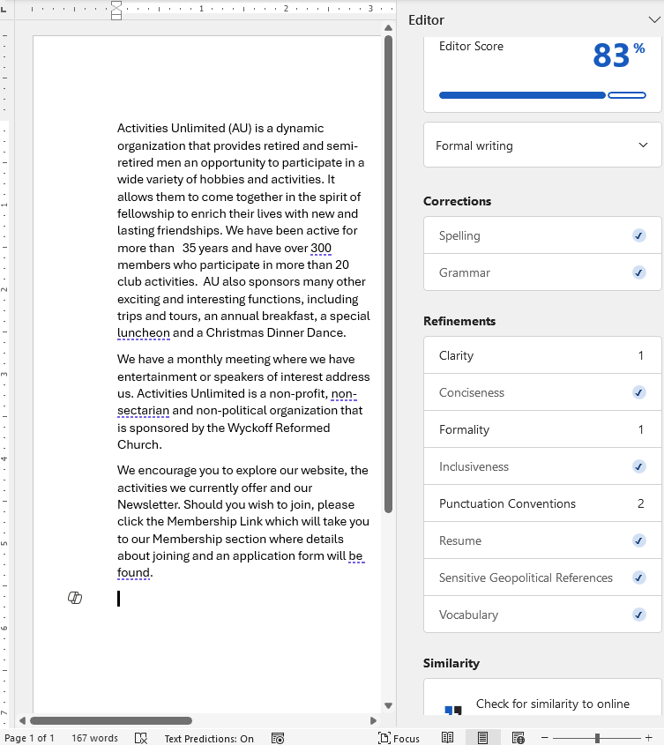

Response:
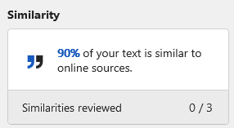

The first paragraph was underlined. When I clicked that, copilot provided this explanation.
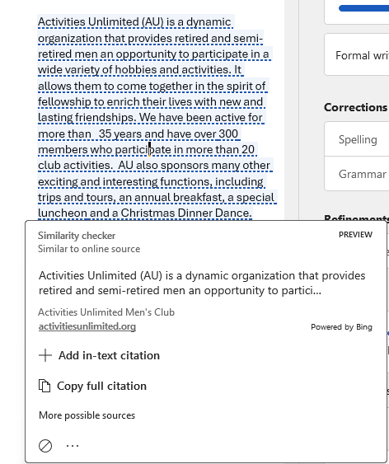

An example of help from copilot. The first sentence I this document has “been typed” underscored. Click on this to see copilot’s response.
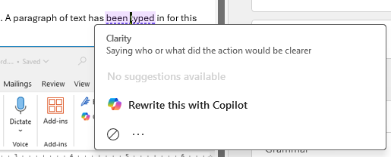

Copilot brings up a work box shown below:
